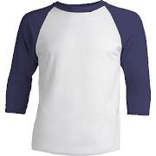

Leadership Tee Shirt

On this tee shirt write down the things you would want an employer to know about your leadership abilities. It can include your experiences, characteristics & beliefs.

*You can decorate your shirt however you like as long as it is appropriate for school.*